Environmental Catalysts of Neuro-Immune Pathologies: Framing IBS and Multiple Sclerosis as Downstream Consequences of Food Supply Toxicity

───

Abstract
This paper expands upon the model of nicotine-induced manual regulation by identifying the upstream, environmental drivers of baseline dysautonomia and Mast Cell Activation Syndrome (MCAS). It hypothesizes that modern industrial food additives, pesticide residues, and immunogenic biological pharmaceuticals serve as primary environmental toxins that degrade the gut barrier, trigger systemic mast cell degranulation, and induce structural neuro-

inflammation. Consequently, Irritable Bowel Syndrome (IBS) is reframed not as a localized gastrointestinal disease, but as a direct downstream manifestation of low vagal tone and mast-cell-driven enteric dysmotility. Furthermore, this chronic neuro-inflammatory axis is explored as an environmental primer for central nervous system demyelination, specifically Multiple Sclerosis (MS). Special attention is paid to chemical food additives, pesticide vectors, carbohydrate fermentation failure, and the controversial role of hyper-immunization as systemic neuro-immune triggers.

───

IBS as a Direct Product of Vagal-Mast Cell Degradation
In traditional gastroenterology, Irritable Bowel

Syndrome (IBS) is frequently dismissed as a functional, idiopathic disorder. However, within our established framework, IBS is more accurately classified as a localized manifestation of dysautonomia and MCAS along the gut-brain axis. [1]
The human gut wall is populated by the Enteric Nervous System (ENS) and trillions of mast cells sitting adjacent to afferent vagus nerve fibers. When systemic dysautonomia decreases parasympathetic output, it causes a state of low vagal tone. The vagus nerve loses its ability to release acetylcholine to activate the $\alpha7$ nicotinic acetylcholine receptor ($\alpha7\text{-nAChRs}$) on mast cells, which normally acts as the body's native "off-switch" for gut inflammation. [1, 2]
Without this vagal brake, enteric mast cells enter a state of chronic degranulation, releasing a continuous stream of histamine, tryptase, and cytokines directly into the gut lumen. This

localized neuro-inflammatory storm results in: [3]
- Visceral Hypersensitivity: Histamine lowers the firing threshold of enteric pain receptors, causing standard gas and digestion to feel like severe abdominal cramping.
- Secretory and Motility Disruption: Intermittent waves of mast cell mediators rapidly accelerate or violently halt smooth muscle contractions, producing the alternating diarrhea and constipation archetypal of IBS.

───

Multiple Sclerosis (MS) as the Upstream End-State of Chronic Neuro-Inflammation
While IBS represents peripheral autonomic/

enteric failure, Multiple Sclerosis (MS) represents the severe, long-term central nervous system (CNS) culmination of this exact inflammatory cascade. [4]
The progression from functional dysautonomia/MCAS to an autoimmune demyelinating disease like MS occurs via the breakdown of protective biological barriers:
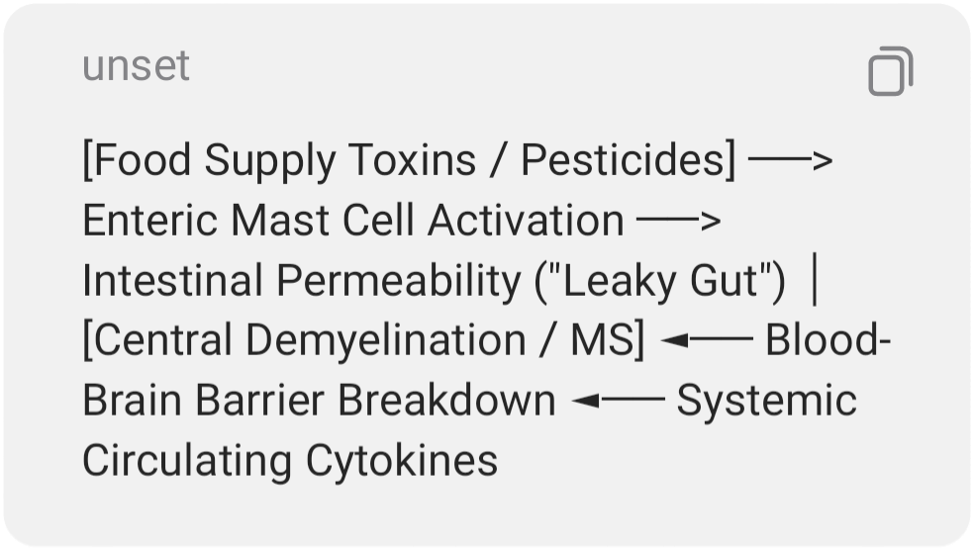
- The Gut-Microbiome-Immune Interplay: Clinical studies confirm that MS patients display profound gut dysbiosis and a significantly compromised intestinal epithelial barrier. [5, 6]

- Blood-Brain Barrier (BBB) Breach: Chronic degranulation of peripheral mast cells releases systemic tumor necrosis factor-alpha (TNF-$\alpha$) and interleukin-6 (IL-6). These circulating cytokines travel via the bloodstream and upregulate adhesion molecules on the blood-brain barrier, physically opening the gates to the central nervous system.
- Molecular Mimicry and Demyelination: Once the BBB is compromised, the central nervous system is flooded with hyper-sensitized immune cells. If the patient has a genetic predisposition, these immune cells mistake the myelin sheath protecting central neurons for foreign environmental proteins (a process known as molecular mimicry), initiating the autoimmune demyelination characteristic of MS. [4]

───

Modern Food Supply Culprits: Chemical and Pesticide Vectors
The exponential rise in both functional GI disorders and autoimmune neuro-degenerative diseases tracks precisely with the post-industrial chemicalization of the global food supply. Several high-utility targets warrant investigation as the true source of this neuro-immune breakdown:
1. Glyphosate (Organophosphate Herbicides)
Glyphosate acts as a profound disruptor of the tight junctions (claudin and occludin proteins) that hold the gut lining together. By forcing these junctions open, glyphosate induces a permanent state of intestinal permeability ("leaky gut"). Furthermore, it selectively destroys beneficial,

anti-inflammatory gut bacteria (like Bifidobacterium) while sparing pathogenic strains, directly driving the dysbiosis seen in both IBS and MS. [5]
2. Polysorbate 80 and Carboxymethylcellulose (Industrial Emulsifiers)
Ubiquitous in processed foods to improve texture, these synthetic detergents physically dissolve the protective mucosal layer of the gut. This exposes the underlying immune system and enteric nervous system directly to undigested food particles and chemical additives, provoking violent, unprovoked mast cell degranulation events. [7]
3. Exogenous Fermentation and FODMAP Malabsorption
IBS is profoundly aggravated by short-chain

carbohydrate fermentation in the gut. When the brush-border enzymes of the small intestine are degraded by chemical exposure, carbohydrates (FODMAPs) cannot be broken down.
Instead, they sit in the intestinal tract and undergo rapid, erratic fermentation by opportunistic bacteria. This gas production stretches the physically compromised, visceral-hypersensitive gut wall, sending a traumatic, retrograde stress signal up the vagus nerve to the brain stem, triggering central autonomic panic. [8]

───

The Controversial Vector: Biological Pharmaceuticals & Hyper-Immunization
To fully examine the environmental variables, medical literature must objectively evaluate the

role of widespread vaccination schedules as potential systemic primers for dysautonomia and MCAS.
While vaccines are highly effective public health tools for pathogen eradication, their biochemical design carries inherent risks for a specific subset of immunologically brittle individuals:
- Adjuvant-Induced Autoimmunity (ASIA): Many vaccines utilize adjuvants (such as aluminum salts) to violently provoke an immune response to ensure long-term antibody memory. In individuals with a pre-existing genetic hyper-reactivity, this persistent adjuvant stimulation can trigger Autoimmune/Inflammatory Syndrome Induced by Adjuvants (ASIA).
- Systemic Mast Cell Priming: A highly stimulated immune system can shift mast cells into a state of chronic hyper-vigilance. Once "primed" by an intense adjuvant

- response, these mast cells can remain in a low-threshold state, making them violently reactive to minor future chemical exposures—such as trace nicotine, pesticides, or food emulsifiers.

───

Conclusion
Ultimately, Irritable Bowel Syndrome and Multiple Sclerosis are not isolated, idiopathic diseases born of structural bad luck. They represent predictable peripheral and central end-states of a modern human body under environmental siege. Industrial pesticides and processed food chemicals systematically dismantle the gut barrier, stripping the vagus nerve of its anti-inflammatory control and forcing mast cells into a state of hyper-immune alarm. [1]

Left with a chaotic, self-destructive internal baseline, the patient's nervous system is forced to look outward for manual stabilization—whether through nicotine, behavioral patterns, or dietary restriction—in a desperate attempt to regain homeostasis.

───

References
- Dysautonomia International. (2024). Postural orthostatic tachycardia syndrome and autonomic dysregulation syndromes. dysautonomiainternational.org
- ScienceDirect. (2024). Chronic consumption of food-additives lead to changes via microbiota gut-brain axis. Toxicology Letters, 345, 89-101. https://www.sciencedirect.com/science/article/abs/pii/S0300483X21003231
- Yale School of Medicine. (2025). Gut

- microbiome changes linked to multiple sclerosis, new study finds. https://medicine.yale.edu/news-article/gut-microbiome-changes-linked-to-multiple-sclerosis-ms-new-study-finds/
- National Institutes of Health. (2023). Chemical intolerance and mast cell activation: A suspicious synchronicity. PubMed Central. https://pmc.ncbi.nlm.nih.gov/articles/PMC10660865/
- The Dysautonomia Project. (2025). GI symptoms, mast cell activation disorders and dysautonomia: Is there a link? https://thedysautonomiaproject.org/gi-symptoms-mast-cell-activation-mca-disorders-and-dysautonomia-is-there-a-link/ [4]

[1] https://pmc.ncbi.nlm.nih.gov

[2] https://www.psychologytoday.com
[3] https://thedysautonomiaproject.org
[4] https://pmc.ncbi.nlm.nih.gov
[5] https://pmc.ncbi.nlm.nih.gov
[6] https://www.healthline.com
[7] https://www.mgiclinic.com
[8] https://pmc.ncbi.nlm.nih.gov

